Lab – Chaining of Watson Services in the server less (Function as a service environment)

Creating Watson Services on IBM Cloud

- Log into IBM Cloud account with your registered Email or IBMid.
- Click on Catalog on the top bar. On the left pane click on Watson under Services.

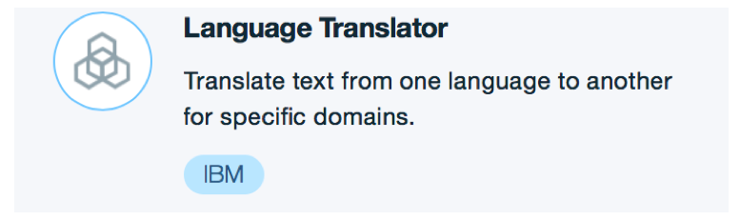

- Select Language Translator and Click to create a new service.
- Provide a unique Service name. If you are not sure what to mention leave the default name provided.
- Leave the Credential name as it is.
- (Optional) Read the Features and Pricing Plans.
- Click on Create.

Note: Repeat the above steps to create Text to Speech Watson Services.

*Step by Step description (for the creation of services with screenshots) is mentioned in Annexure.

Now, Click on the Functions tab on the left hand side menu.
Click on Functions to start creating your cloud function leveraging Openwhisk.

Click on Start Creating Button and click on create action button.

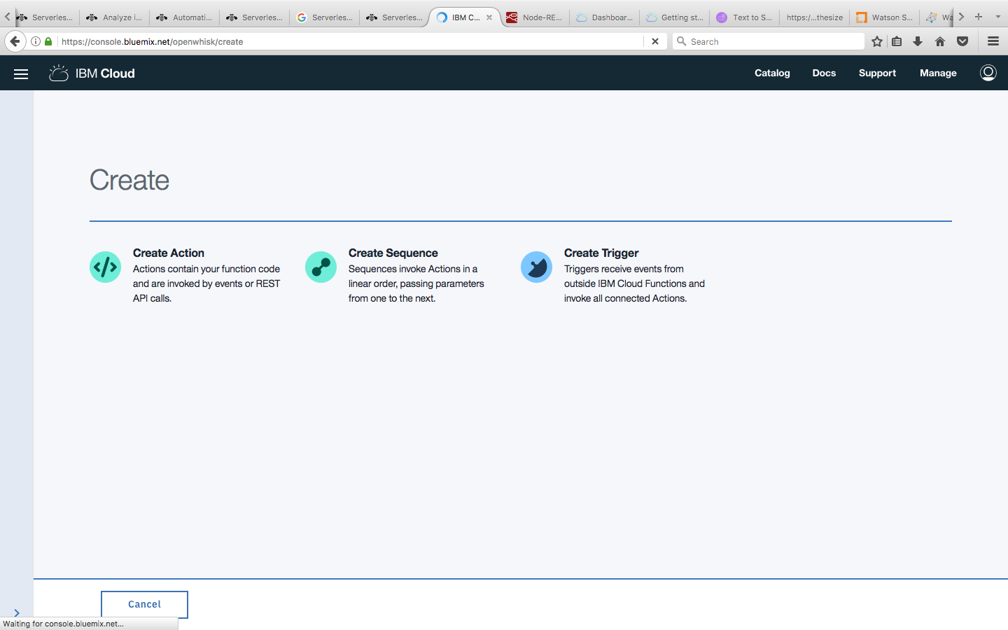

Give a name to your action like “mySwiftAction” as an example.
Keep Enclosing package as it is, select Swift as runtime from drop down and click create.

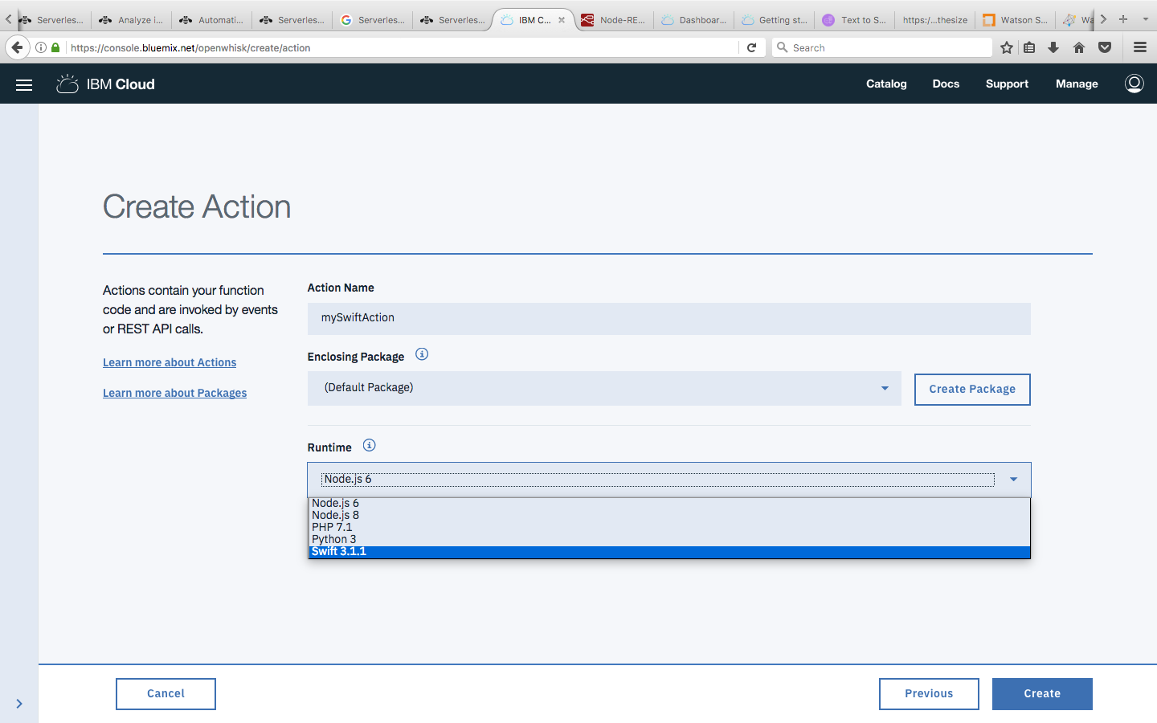

Replace the existing function code with the code below

func main(args: [String:Any]) -> [String:Any] {

if let message = args["message"] as? String {

return [ "payload" : "\(message)!" ]

} else {

return [ "payload" : "Hello stranger!" ]

}}

Note: As output of one action is input to the next action, The JSON with payload will be an input to the next action you create in the sequence.

Click on Save on the top right corner
Now Click on Invoke to see the results as desired.

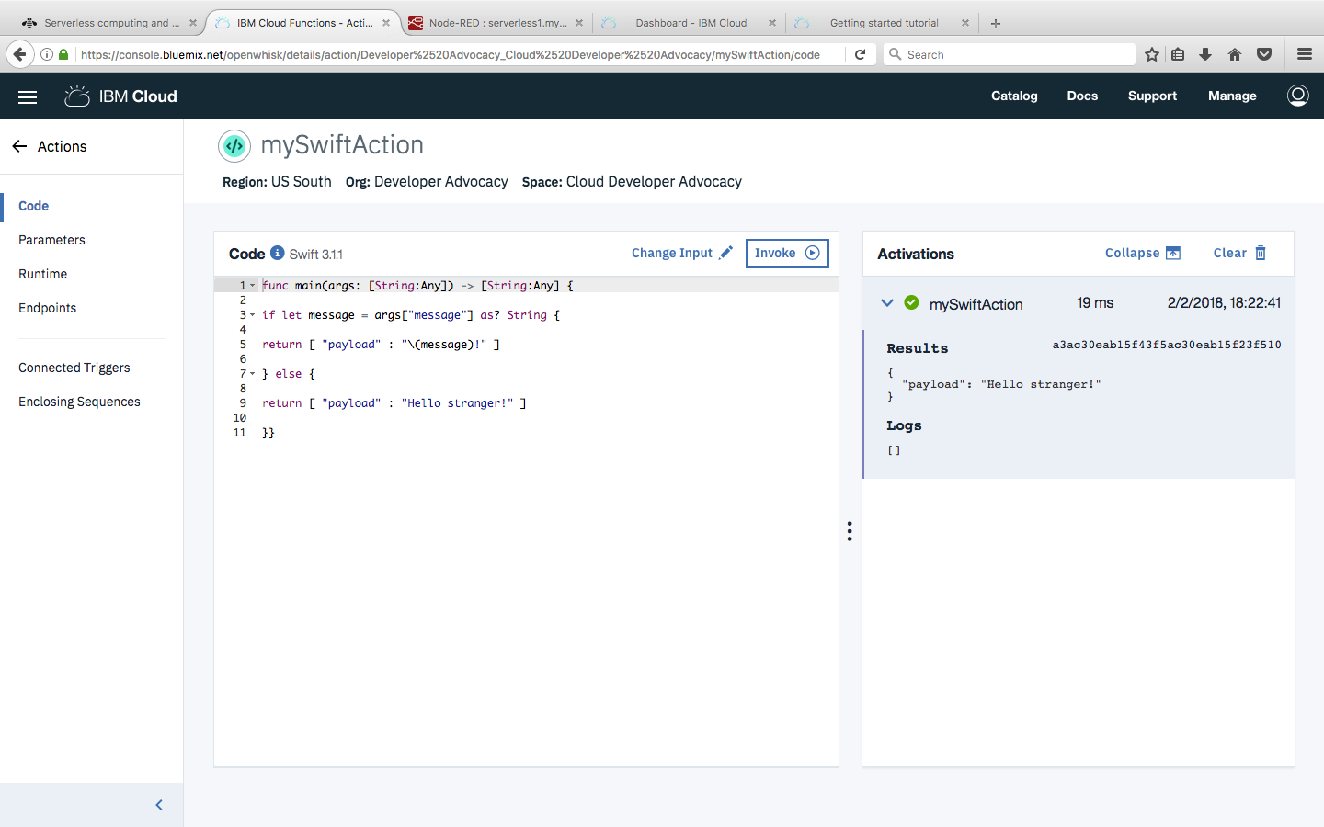

Go Back to Start Creating button

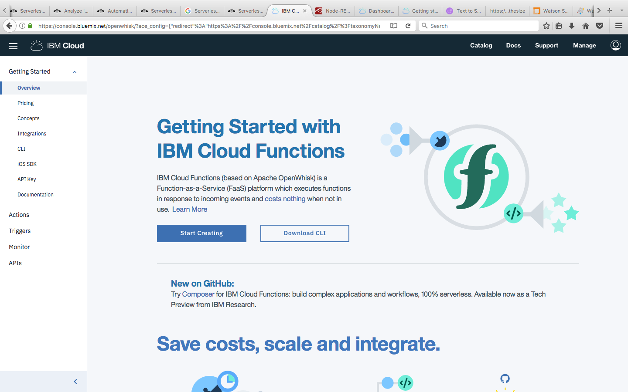
and then click on Create Sequence button

Give a name to the sequence and keep default package as it is.

From the Select Existing drop down select the previously created Action
Click Create

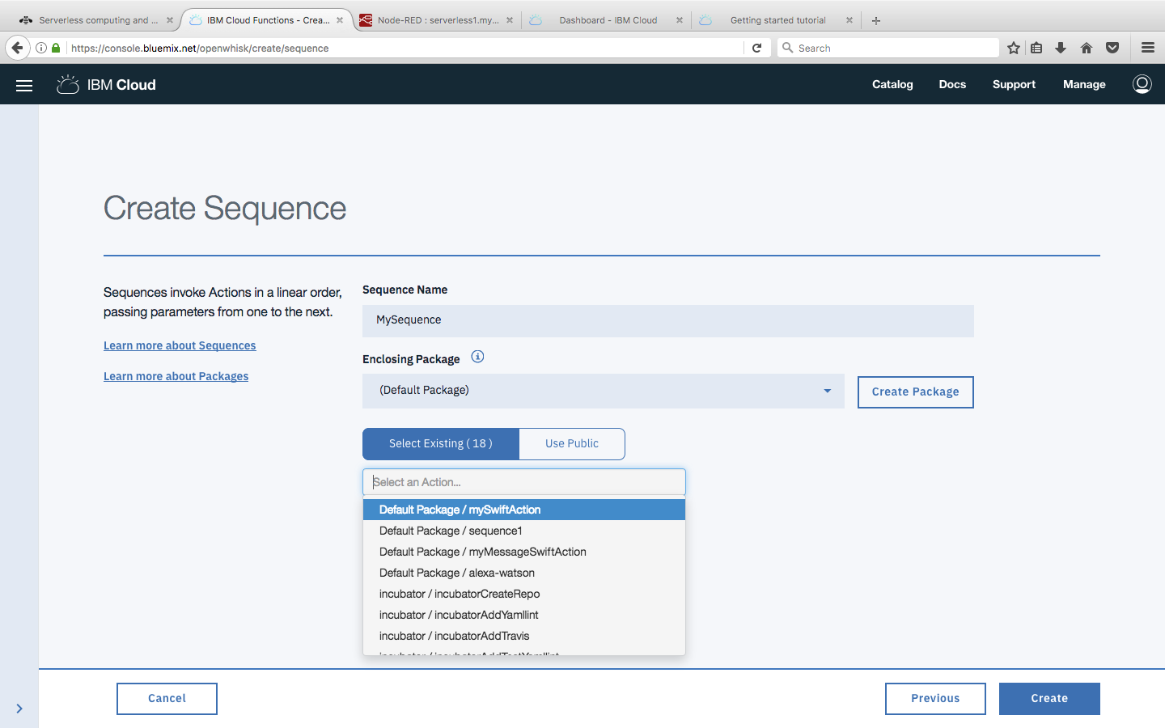

Now you can see the sequence is created with an action on it.
Click Add(+) button to chain Watson services(Translator & Text To Speech)

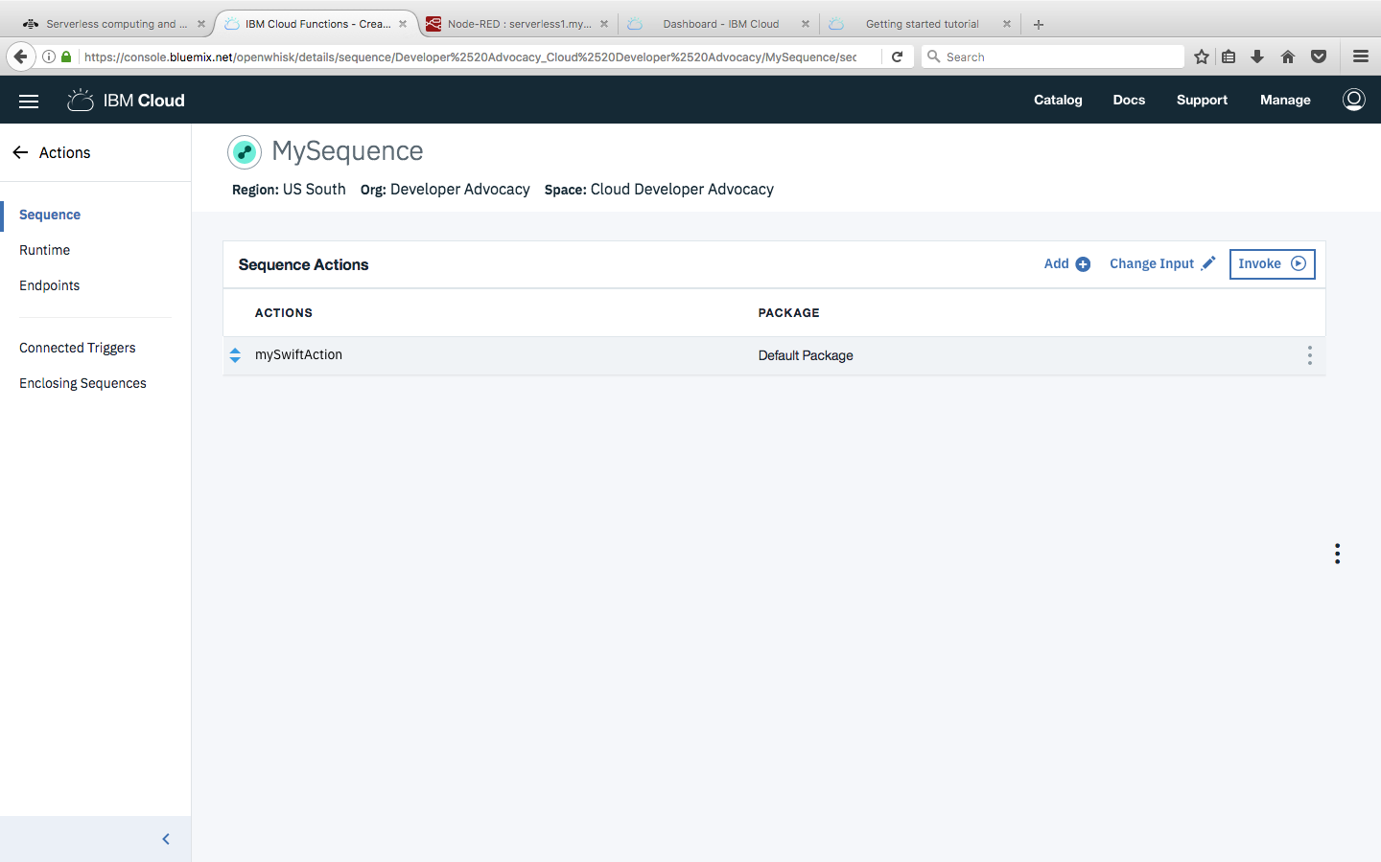

Click on Use Public button and select Watson translator

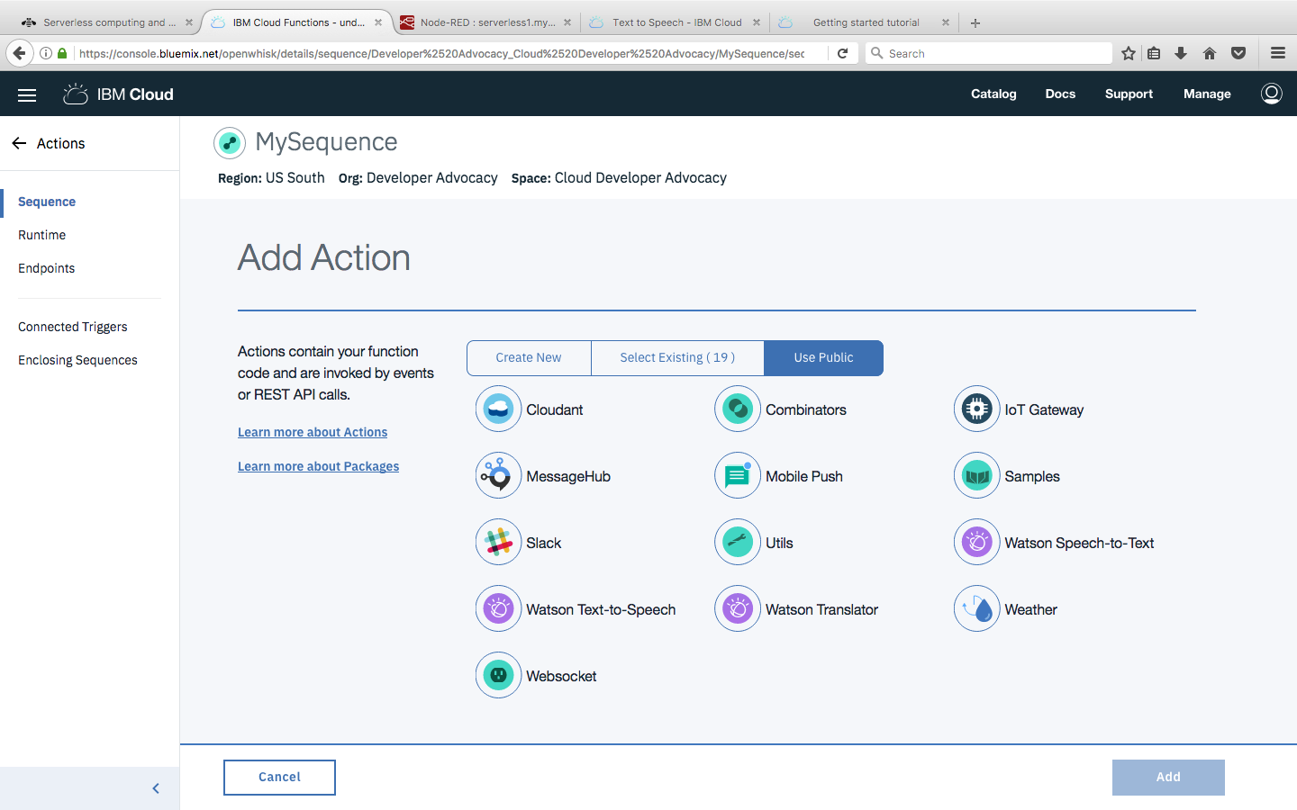

Select translator from Actions in drop down menu

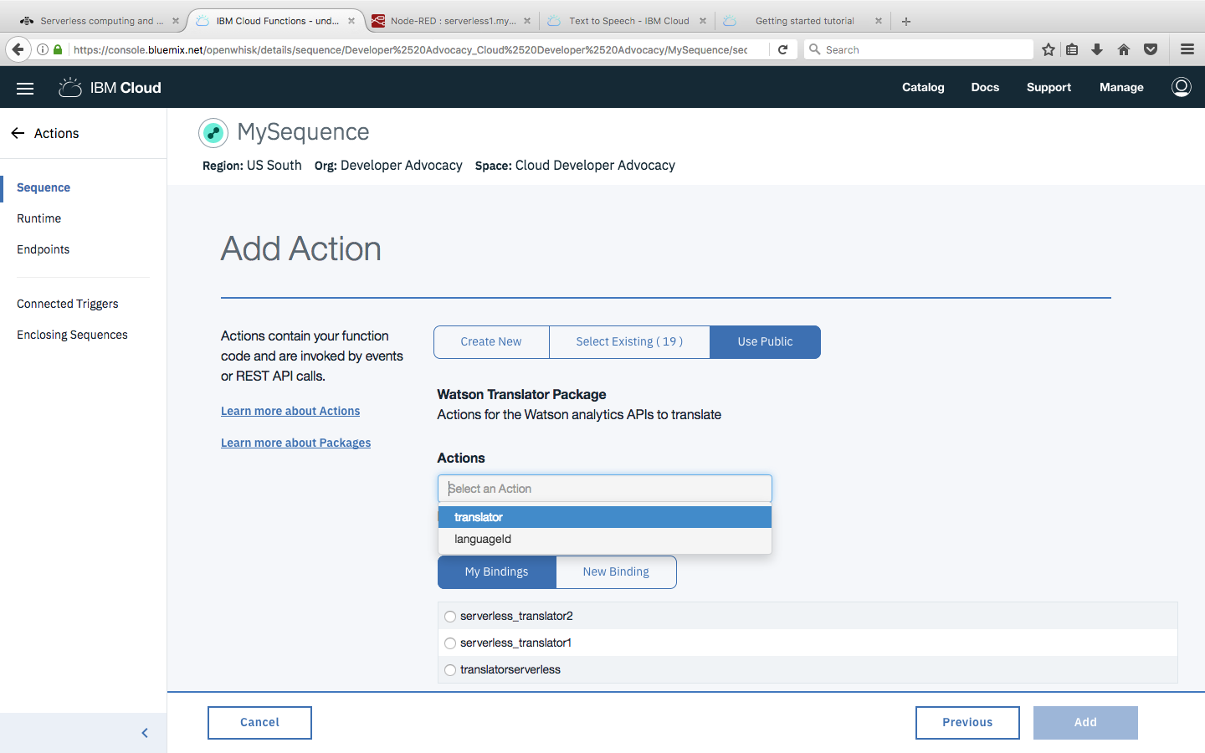

Select “Input your own Credentials” from the Instance drop down menu and enter your credentials (user name & password) from the Translation service.
Click Add
Now, you can see the translator service chained to the sequence
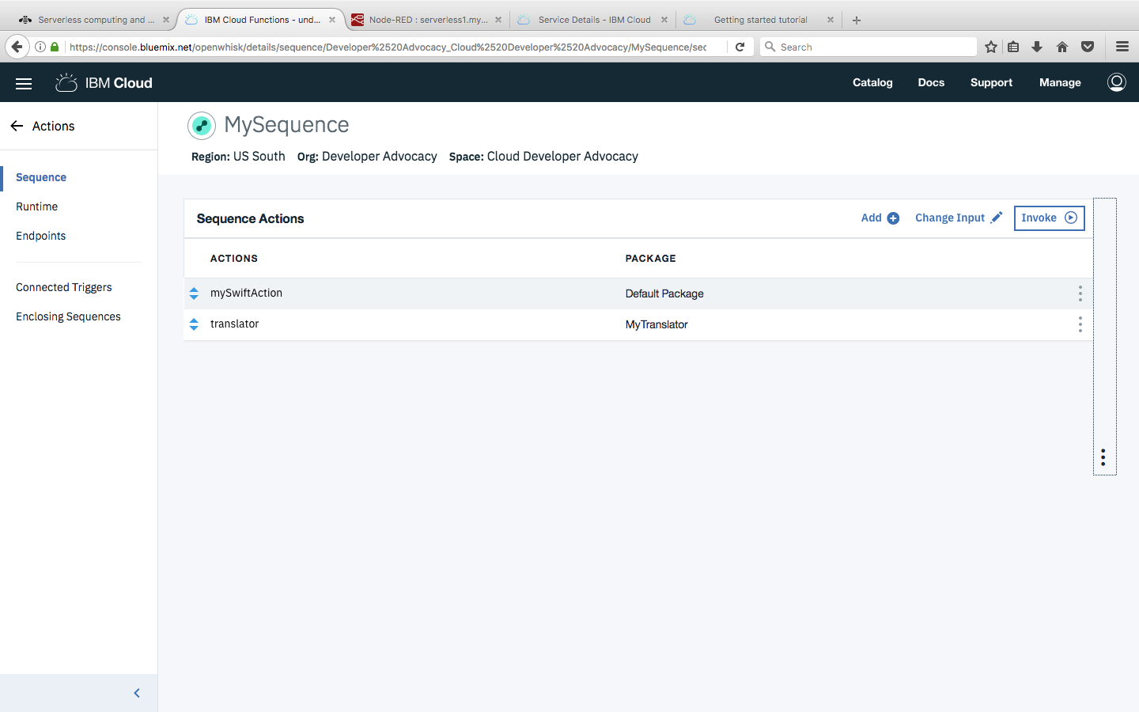

Click on save and invoke to see the results
Hello Stranger --> Bonjour etrange

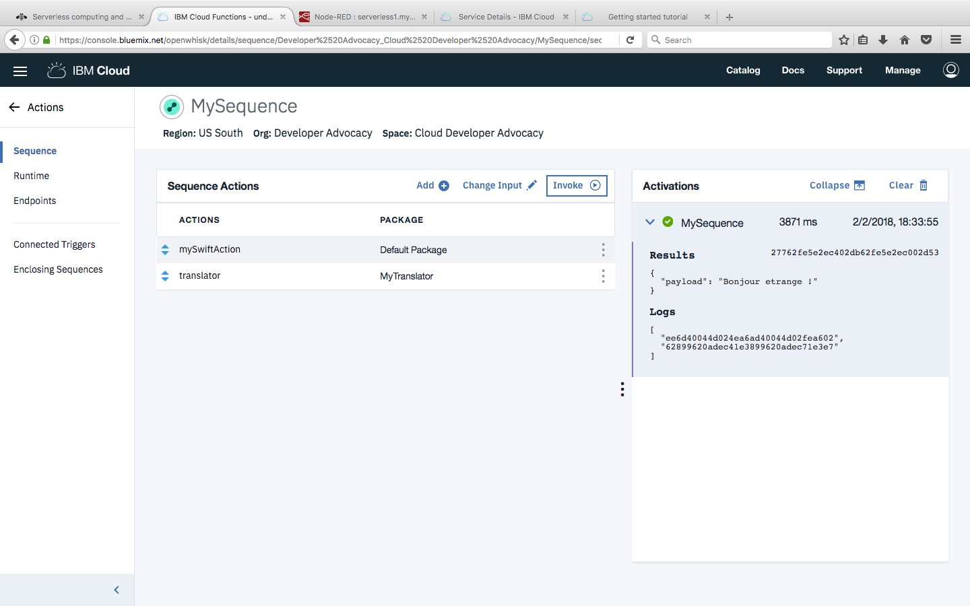

Repeat the same steps to chain Text To Speech into the sequence
Starting by clicking the Add(+) button.

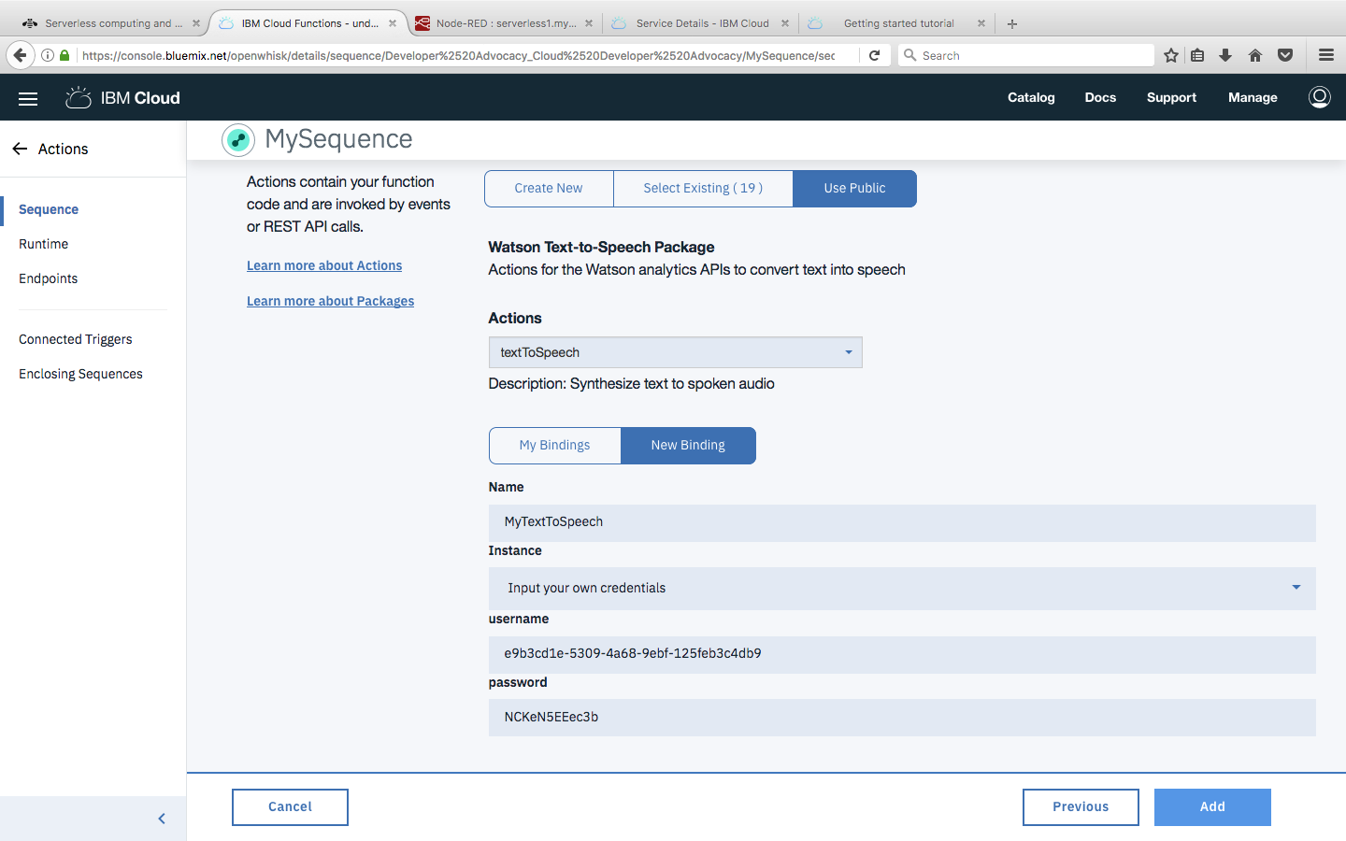

And now you can see the Text To Speech Service chained to the sequence

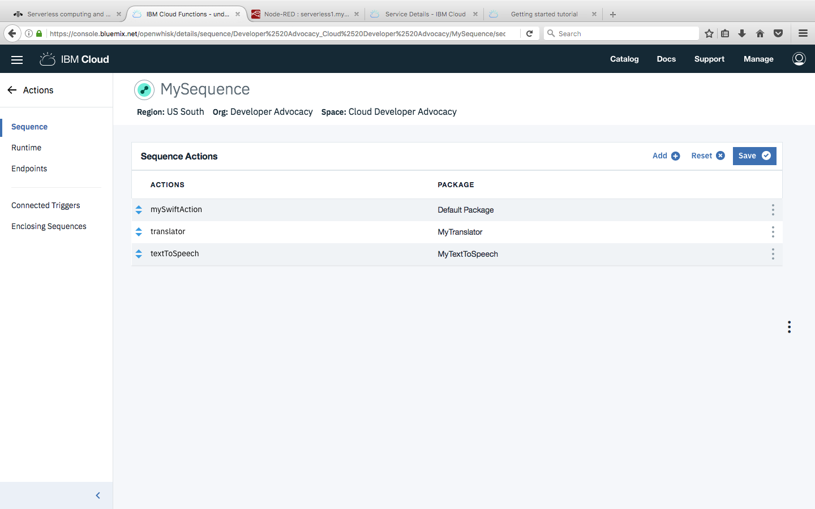

Click Save and Invoke to see the result as the Base64 encoding of the audio file which can be synthesized to create audio/sound file.

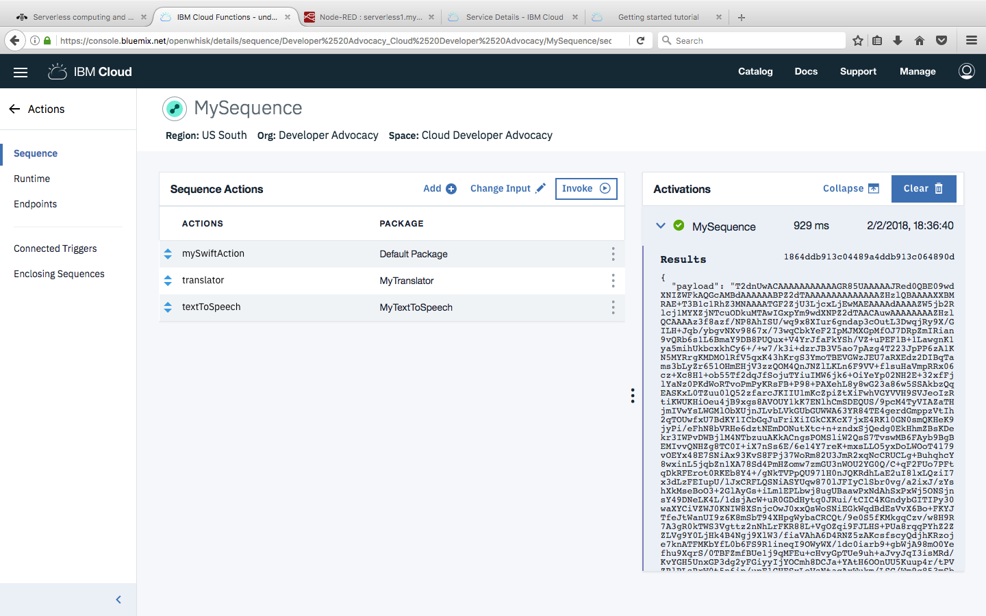

Annexure:

Creating Watson Language Translator & Text To Speech Services

Click on Catalog
Scroll down to Watson and select language Translator
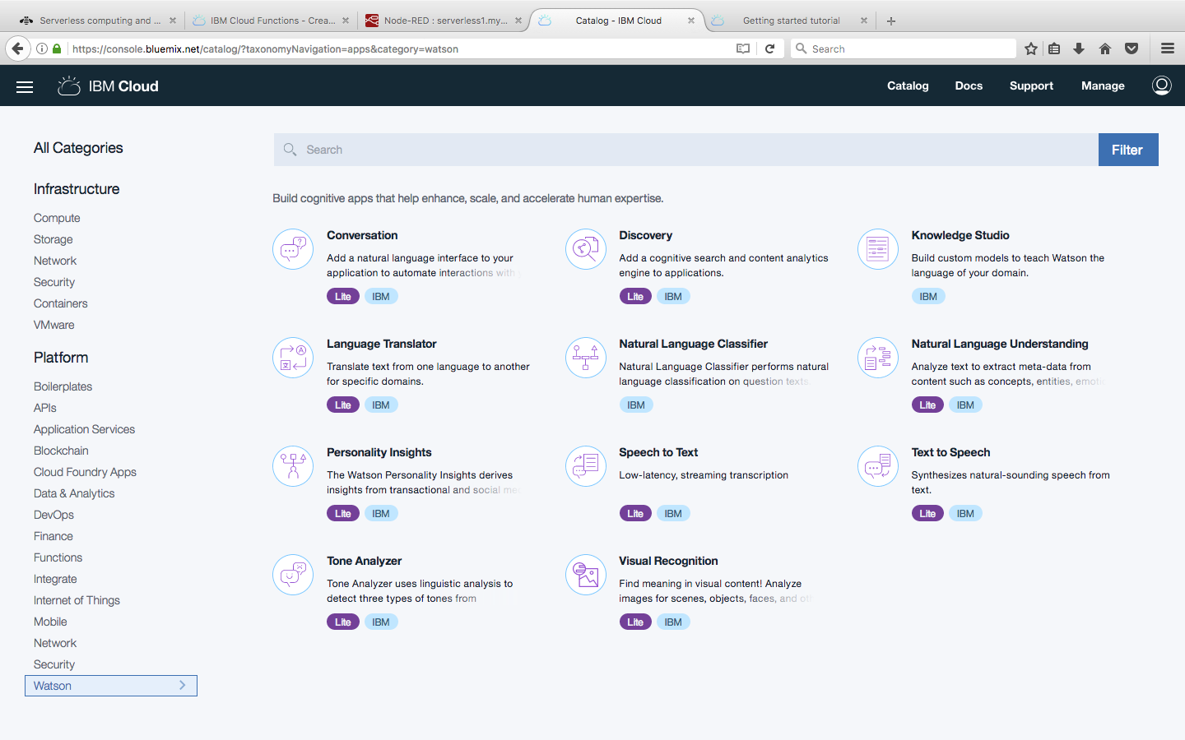

Click Create

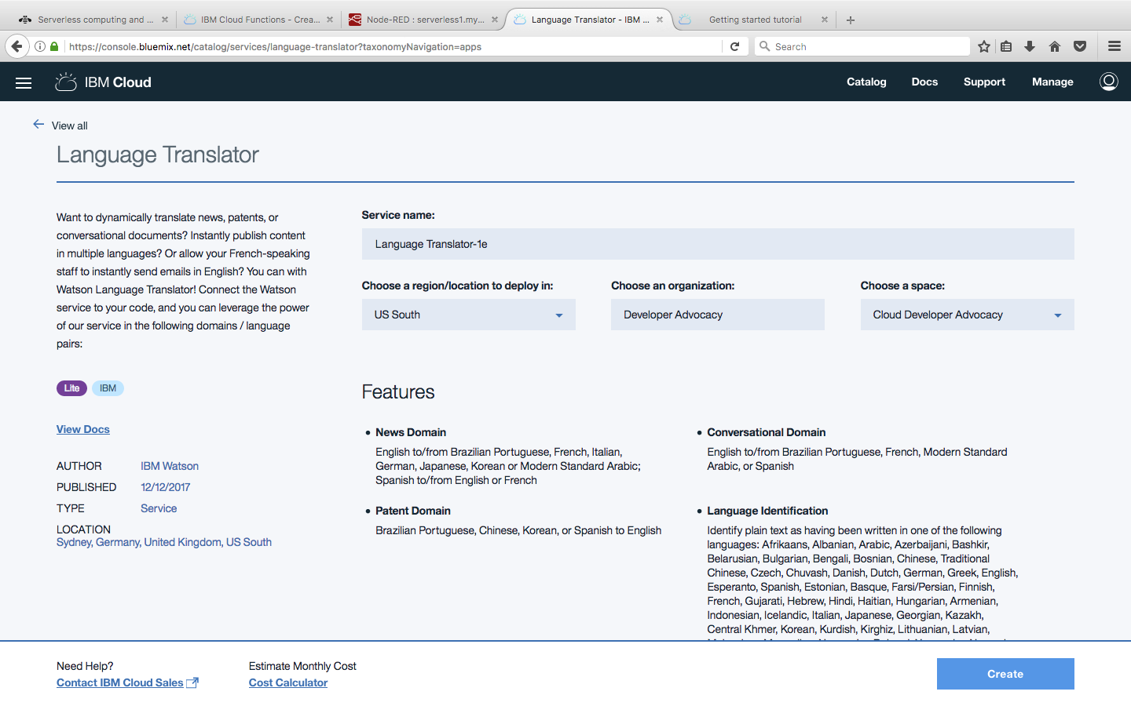

Click on Service Credentials
Click on New Credentials

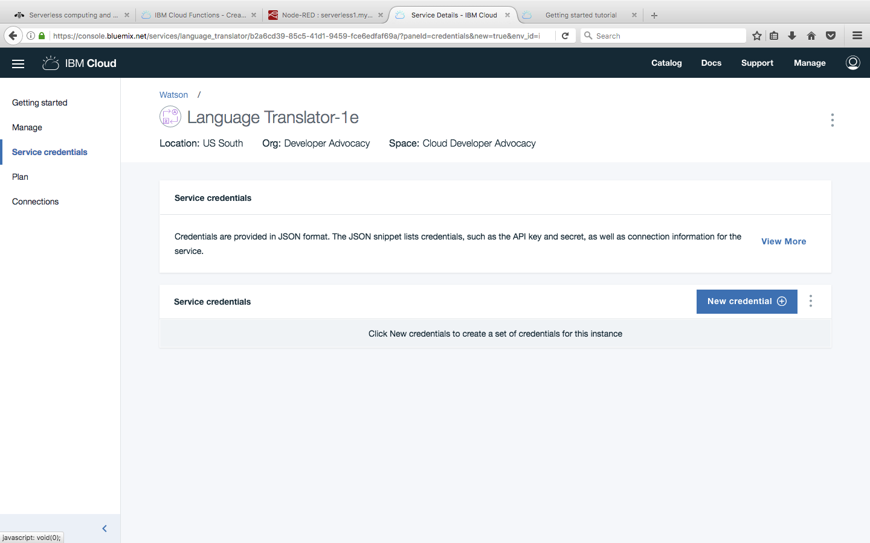

Click Add

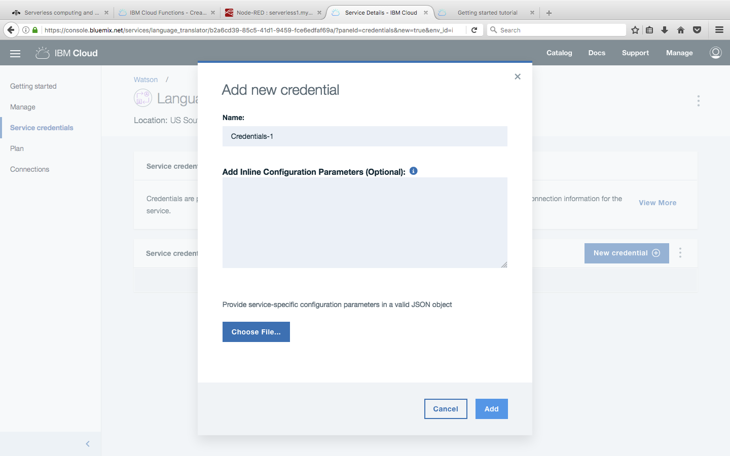

Click on View Credentials save username and password for later use.

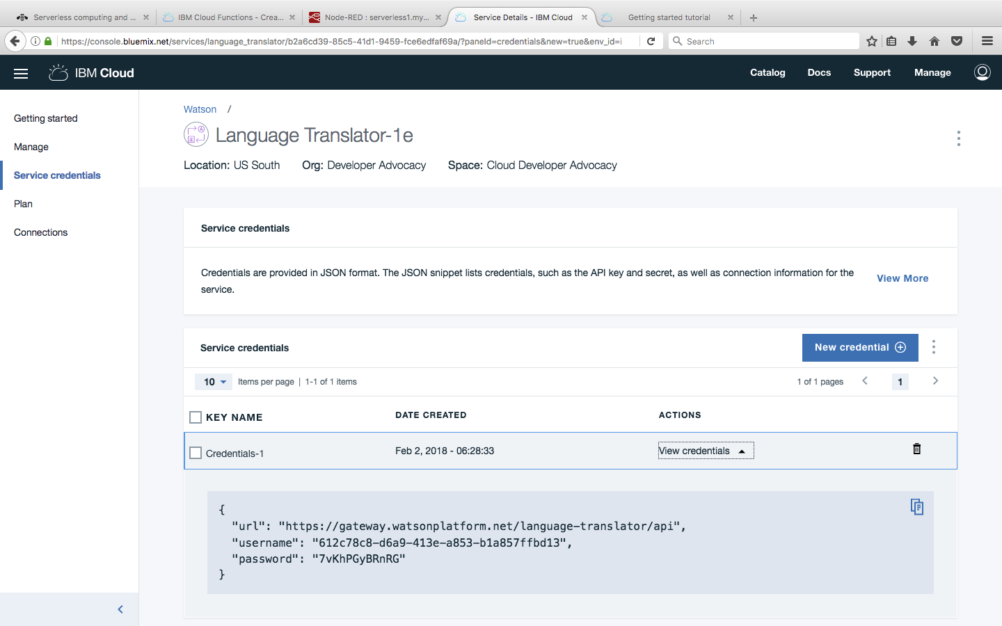

Repeat the same steps to create and save the credentials for Text To Speech service.

You will be able to complete this lab in 15 mins.
Thank You!!

